



Carol Service 6.00
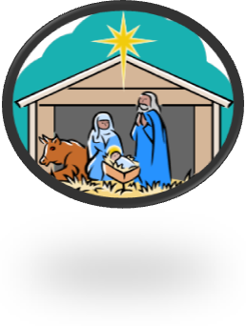
Sunday 18th
Christmas Eve 4.00
Crib Service
11.30 ‘Midnight’ Communion
Christmas Day Services 8.00 and 11.00

